MQL PROCESS DOCUMENTATION
Bennardo, last updated 9/18/2024

High Level Steps for Processing an MQL
- Receive the MQL in SalesForce.com
- Qualify the MQL for sales
- Update required fields
- Write appropriate notes
- Assign the lead to sales OR close the MQL
- Notify sales stakeholders via email
The details below cover the required steps for processing an MQL that are generally common across all segments and solutions. This will not answer all of your questions about every specific situation, but will at least give you the order or operations and some context for why we need to do some of these things. Many of the details left unexplained are those that vary by segment or solution.
I have also not attempted to explain all the uncommon situations that might come up. You will likely (but hopefully rarely) encounter errors or other situations not covered in this document.
The MQL process is somewhat meticulous and requires some attention to detail, but it is not as complex as it appears. To set your expectations, processing a single MQL from start to finish may take around 15 minutes, depending on how much needs to be done.

Detailed Steps for Processing an MQL
- Receive the MQL in SalesForce.com
MQLs will be assigned to you by the system as Tasks. You should have access to a Task Report called "My Open MQL Tasks". This report will display a list of all MQL Tasks currently assigned to you which have not been closed.
This is the report I use as my worklist for MQLs. I work through the list by either reassigning or closing each of the tasks on the list. Reassigning or closing the tasks removes them from the report view and allows me to have a clean view of all new MQL Tasks that need to be processed. I generally do not let a task sit open for more than a few days at the longest -- if a task is open, it means I need to take some action to resolve it.
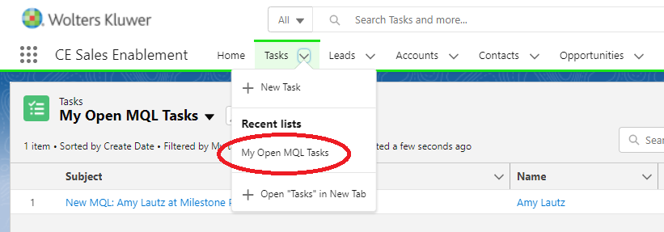

MQL Tasks in SFDC are the "source of truth" for sales leads. There is no alternate process to pass along a sales lead outside of the MQL process in SFDC. Only properly assigned MQL Tasks will be captured in our marketing reporting.
All MQLs in SFDC start first in Marketo, which is where lead scoring occurs. All MQLs must meet the scoring threshold of 75 points. There are some actions that are instantly scored at 75 points.
Practically all MQLs you receive will come from one of these sources:
- Form fills on the website: A prospect or customer fills out a "Contact Us" form. This is considered an automatic 75 points.
- Lead loads from events or other sources: A marketing manager loads a list of leads that were collected from marketing activity. There is a template that can be used for this which includes a field to indicate whether the lead should be scored at 75 (contact requested) or not.
- Marketing creates a single MQL: A marketing manager enters information into a specific form to create a single MQL. This is used most often when customer/tech support or other divisions pass over sales leads that are not otherwise in the system.
- Vendors pass MQLs through automatic processes: Some of our vendors are integrated into Marketo and can automatically pass MQLs into the system. Our telemarketing vendor (Televerde) is the most prominent example of this.
- Organic MQLs that result from lead scoring: A lead in Marketo registers sufficient activity to hit the 75 point threshold and becomes an MQL.
- Reassignment from another market manager: A market manager receives an MQL that is not intended for their segment or region, and reassigns it to you in SFDC.
Regardless of the source of the MQL, all MQLs should flow automatically from Marketo into SFDC. For most types of MQLs, as this happens you will receive a system notification from SFDC. (Sometimes these notifications are sent to the wrong person or otherwise fail to trigger. They are not 100% reliable.)

- Qualify the MQL for sales
The degree to which marketing qualifies sales leads varies by segment. In the International segment (which our team does not support), marketing country managers engage in extensive qualification that can involve nurturing MQLs via phone and email conversations.
In the Provider and Commercial segments, our qualification process is much less involved. Generally, our task here is simply to determine whether the lead is appropriate for the salesperson we pass it to, not to nurture the lead ourselves.
We are looking for the following things to determine whether the MQL is appropriate for enterprise sales:
- Does the lead express sales interest in one of our solutions? (As opposed to being a support request, content question, or other type of inquiry.)
- Is the lead in the correct region? (For us, this means the solutions will be used by providers or companies who are primarily based in the United States or Canada.)
- Is the lead in the correct segment? (Fairly regularly, Commercial will receive an MQL that is better for Provider, and vice versa.)
- Is the lead an appropriate size for enterprise sales? (As opposed to being a lead for the Individual segment. The rules governing this vary by segment and solution, but are generally well-defined.)
If the answer to all of these questions is "yes", then the MQL can be passed over the sales. Sometimes a lead will still look interesting even if one or two of the answers might be "no". In those cases, it is appropriate to reach out to sales to ask them if they would like to speak to the lead. Some examples:
- The MQL did not ask for sales outreach, but reached MQL status through organic scoring. If they otherwise look like a "good" lead (based on title, organization, marketing activity, etc.), then sales may want to reach out to them proactively.
- The MQL is inquiring about a need that is not an exact fit for the solutions we offer. In certain cases, sales may still want to explore their need and see if we can help them. (This is especially relevant for Medi-Span, which has more complex use cases than the other solutions.)
- The MQL represents an institution that would ordinarily be an enterprise customer (such as a hospital), but says they only want a few individual licenses. In this case, sales will very often want to try to sell them an enterprise license before allowing them to buy individual licenses.
Sometimes, it may be necessary to communicate with the lead to clarify one or more of these points. This is generally done over email, often using pre-written templates. If they do not respond to the first email, our standard is to contact the lead at least twice before closing the lead. (And in some cases, I would still ask sales if they want to take the MQL even if they don't respond the second time.)
Communication with the sales lead generally only happens with Provider leads. Commercial sales prefers to receive all MQLs and make the first outreach themselves.
In the end, not every MQL will be an appropriate lead for enterprise sales. It would not be uncommon if half of your MQLs were not passed to enterprise sales. What happens to the MQL after that can vary, but the most common next steps are:
- Reassign the MQL to a different region or segment.
- Send the details via email to customer support for assistance. (Unfortunately, support is not currently using SFDC, so MQLs that need support cannot simply be reassigned.)
- Send the details via email to the Individual segment for assistance. (Unfortunately, this segment is not currently using SFDC either.)
- Close the lead without further action due to non-response.
In all these cases, the objective is still to either reassign or close the lead. This will remove it from your task list.

- Update required fields
When preparing an MQL for sales, we need to ensure that all the required fields are filled in to allow for the necessary reporting and notifications. This includes fields on both the Task and the Lead records.
TASK FIELDS
- Primary Campaign Source -- Despite the name, we do not use this field to track campaign sources. Instead, we use it to associate the lead with one of the sales playbooks. This field is never filled in automatically and will always need to be manually set. Occasionally, there are MQLs that do not align with any playbook. In that case, the field can be left blank.
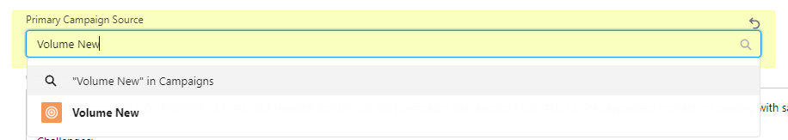
- Product Interest and Lead Status -- These fields are usually filled in automatically, but sometimes they are blank or have incorrect values. Product Interest should reflect the current solution interest, and Lead Status should be "MQL".
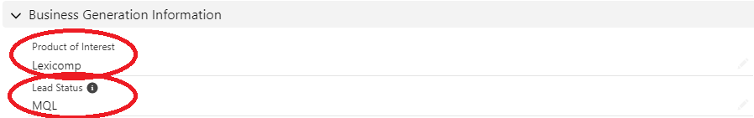
- Qualification Date -- This field should be set to the current date when the MQL is assigned to a sales rep. This is important, as it drives flags in SFDC that will tell sales they need to take action on the MQL.
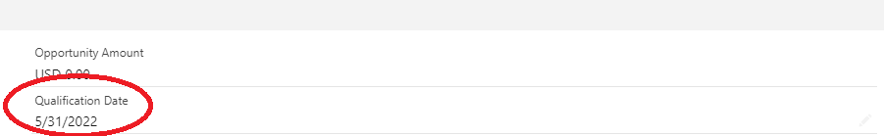

- Set Reminder – Set a reminder three days after the qualification date.
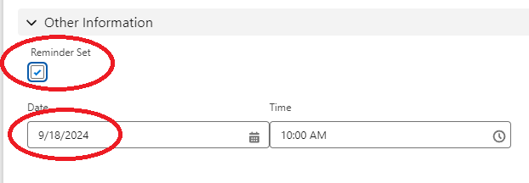
LEAD FIELDS
- Existing Account -- Sales has asked that we associate leads with existing accounts in SFDC whenever possible. It is not always possible to do so, but we always should make the attempt. Sometimes, a company will already be associated when the MQL is received. Otherwise, a search on Company Name or Address in SFDC will often lead to the correct account in SFDC. When you are able to identify an existing account, update the “Existing Account” field on the Lead record to reflect this.
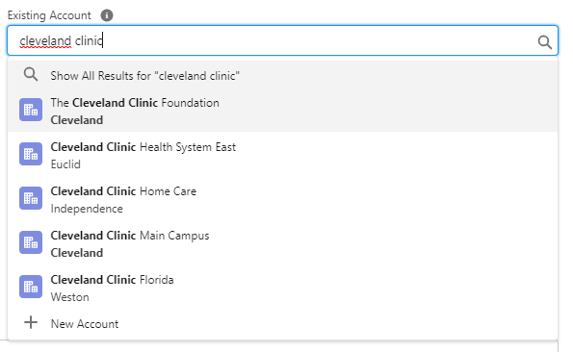
- Other fields not correctly populated -- There are a number of fields on the Lead record that are often not correctly populated and need to be filled in before a Lead can be reassigned. (When you try to save your changes, an error message will tell you which fields need to updated.) The most common fields this affects are Title Category, Segment, and Sales Region. For our team, Sales Region is always “USCAN” and Segment is always “Provider”. The other fields should be populated with the most appropriate selection for the individual lead.
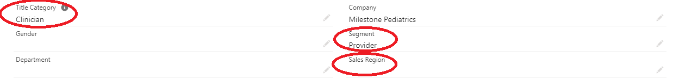

- Copy/paste task notes to the lead – Simply copy the notes from the Task to the Lead.
- Errors on Lead page – If you are unable to update the Lead record due to errors, please notify Don and Matt. We can demonstrate how to fix this. It is most often the result of an incomplete address on the Lead record.

- Write appropriate notes
For MQLs that will be passed to sales, reference the template provided in the other document.
For MQLs that are not passed to sales, I generally note the actions I have taken and the reasons I am closing the MQL. For instance, I will note if I am passing the lead via email to Customer Support or the Individual team, if I have not received a response to my outreach, if I have identified the MQL as a duplicate or one with no sales potential, etc.
See a few examples below. In this context, "Disqualified" refers to a specific disposition that closes MQLs that are not passed to sales.

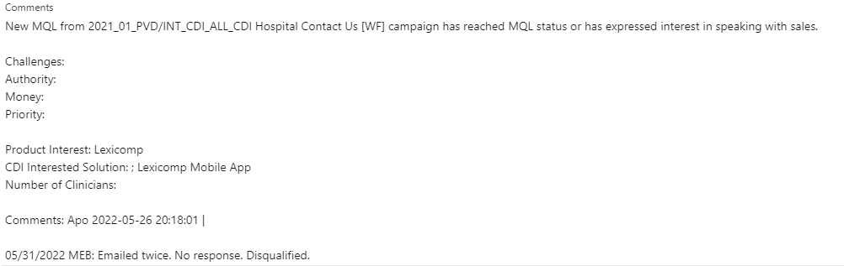

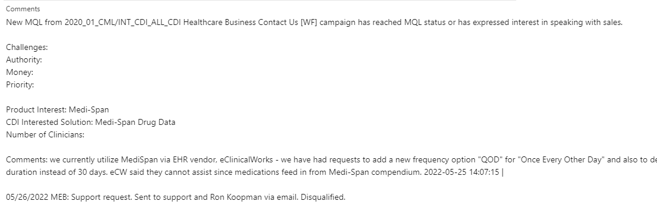

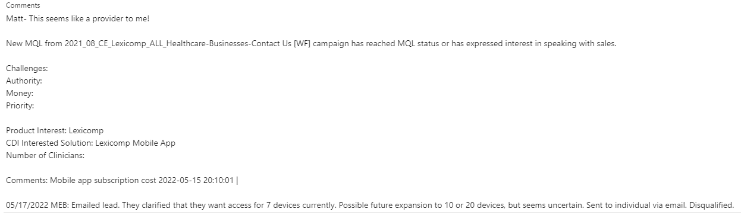

My notes are generally brief and follow formulas similar to those shown in the examples. Occasionally, I may need to summarize conversations I have had with the lead and/or others internally. In those cases, the notes may be more extensive.

- Assign the lead to sales OR close the MQL (Disqualifying an MQL)
My goal is always to either assign an MQL to somebody else or to close it, as these are two actions that will remove the MQL from my task list. Most of the time, I can do this within the same day I receive the MQL. Sometimes, I need additional information from the lead or from someone internally. In those cases, I try to resolve the MQL within a few days. In rare cases when a lead is unresolved after that time due to missing information, I make my best effort to resolve it in the way I think is most appropriate with the information I have.
ASSIGNING AN MQL TO SALES
To assign an MQL to sales, you will first need to identify the correct sales rep. In general, to reliably route an MQL to the correct sales rep, you will need to know (1) segment, (2) solution, and (3) geography (preferably ZIP code). This information is usually available on MQLs when they come in, but occasionally will need to be researched.
Routing rules can be complex, but they are fairly well-defined. (In other words, there is usually only one "correct" answer of who should get an MQL.) Much of the nuance is currently in the heads of the various market managers and needs to be formally documented. When in doubt, refer to the “routing rules” spreadsheet.
Sometimes it is unclear which segment a lead should belong to. This may require either research about the company or discussion with other market managers to resolve. For difficult cases, please consult with Don and Matt.
Occasionally, a salesperson will ask that an MQL be reassigned to a different salesperson. When this happens, I try to understand the reasoning behind the request. Sometimes they have information I don’t have about the lead, and sometimes they have a different understanding of the routing rules. In cases where sales seems to be asking for an assignment that goes against your understanding of the rules (without an extenuating reason), please reach out to Don and Matt.
To assign an MQL to sales, you will need to change the ownership of both (1) the MQL task, and (2) the lead record (in that order!). Specifically, you will change the ownership from your name to the name of the salesperson receiving the MQL. The process is the same for MQLs that need to be reassigned to other segments or regions, except you will change the ownership to the market manager responsible so they can route according to the rules of their segment/region.
Both the Task and Lead will need to be assigned to the same salesperson to give them the necessary permissions for them to work the lead. Unfortunately if you reverse the order from what is shown above, SFDC will fail to send a notification to sales informing them of the change in ownership.
Once you have reassigned the task and lead, the MQL will no longer appear in the My "Open MQL Task Report".
DUPLICATE MQLs – Guidance to come.
DISQUALIFYING AN MQL
To close an MQL that is not going to enterprise sales, you will need to update two fields on the Task: (1) Lead Status, and (2) Reason Not Qualified.
Changing the Lead Status to "Disqualified by Segment Marketing" will close the task. After this change is saved, you will then need to make a selection in the "Reason Not Qualified" field. (If you try to change both fields simultaneously without saving in between, the system will not always register the update to the "Reason Not Qualified" field.)
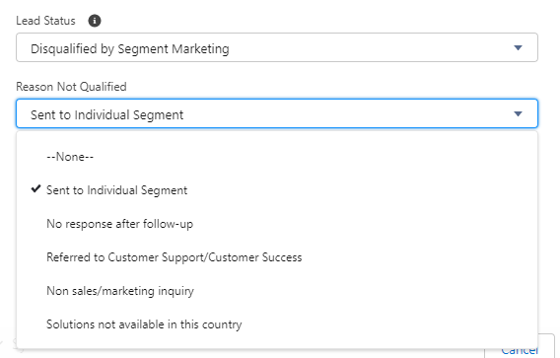
The list of reasons not qualified does not always cover all the reasons that a lead might be disqualified. For example, there are sometimes duplicate MQLs, test MQLs, or false/erroneous MQLs. For reasons not covered in the list, I generally select "Non sales/marketing inquiry".
Once these two fields are updated, the MQL will be marked closed and will no longer show up in your "My Open MQL Task Report". You do not need to change the ownership on MQLs that are closed this way.
Note: It is rare that I close a lead in this fashion without taking any action at all. If I am closing a lead that was generated by a webform fill, I will have either forwarded to somebody else in the company to assist, have communicated with the lead and determined they do not need follow up, or have communicated with the lead and received no response.
Sometimes an MQL that is generated by lead scoring will have no sales potential (e.g., they are already a customer of the solution) or is obviously false/erroneous (e.g., sometimes updates that are made in the system will result in changes in scoring that are not reflective of actual lead activity). In those cases, I may close the MQL without taking further action beyond researching the lead.

- Notify sales stakeholders via email
In SFDC, an MQL can only be assigned to one individual. However, sales has requested that we notify multiple people for each MQL that we assign to facilitate prompt follow up and information sharing. This generally includes some combination of: (1) the sales rep receiving the MQL, (2) their leader, (3) other sales reps or leaders associated with the territory, and (4) sometimes a product specialist for the specific solution.
The email also gives the receiving salesperson a specific contact (me) who they can respond to with questions if they do not understand what they are receiving, and helps foster better relationships between marketing and sales.
The list of who needs to be included will vary by segment and solution. The spreadsheet I have started to document routing rules also includes information on who needs to be notified for each MQL.
I generally include similar information in this email as I do in the notes on the MQL. An example email is below.
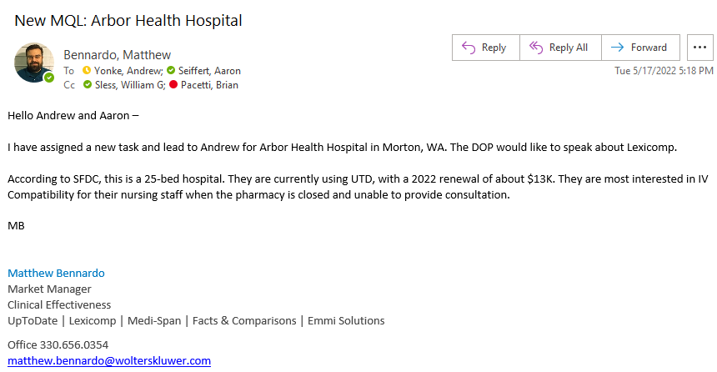
Sales will sometimes reply to these emails, but often they do not. The replies should be monitored in case they include any requests to reassign the MQL or any questions that we are able to answer.
Note: Because we are the point of contact for MQLs, sales will sometimes reach out to us for general SFDC support. This is not our role, and questions about anything other than MQLs should usually be directed towards SFDC support or sales ops.

Update the tracker spreadsheet
Include in tracker:
- MQLs for Provider, Commercial, Individual
Can we create a report in SFDC that would allow for this?

